

SUBJECT:-INTERNET PROGRAMMING
SUBJECT CODE:-CSE 326

TOPIC:-ONLINE SHOPPING WEBSITE. (PROJECT NO. 20)

SUBMITTED BY:- SUBMITTED TO:-
SAHIL 58 11908312 Ms. MANU BALI
AKSHIT RAWAT 59 11908341
PRATEEK NANDA 60 11908352

CLASS:-K19GE

ONLINE SHOPPING WEBSITE

OBJECTIVE OF PROJECT
The development of technology in the present, especially in the field of technology and information is growing very rapidly. In this very advanced era, very often we hear about internet technology which is a recent development of a highly advanced information technology. The development of Internet technology in this highly developed era is more dominant in the direction of user-friendly, the ease of consumers in understanding and also using the function of the internet. The use of the Internet as a medium in terms of spending has empowered buyers with lots of benefits and also its own advantages. With the increasing popularity of online shopping and being the most populated country in the world, China is one of the largest online markets now and is likely to become the largest market in the future. In the academic literature, website quality has generally been recognized as a critical step to drive business online.

PROJECT DISCRIPTION
The concept of standard methods that have been very often used by developer’s web makers, namely by using the method "Waterfall". Which originated and started from: Planning, Design, Code, Testing System and Development
In the process of building an online store website using Hyper Text Markup Language, the programming language has to go through various stages, namely the stages of data collection, problem analysis, database design and the last is the implementation of the online store website itself. Techniques of data collection used i.e.; through Interviews, Observations and Library Studies.

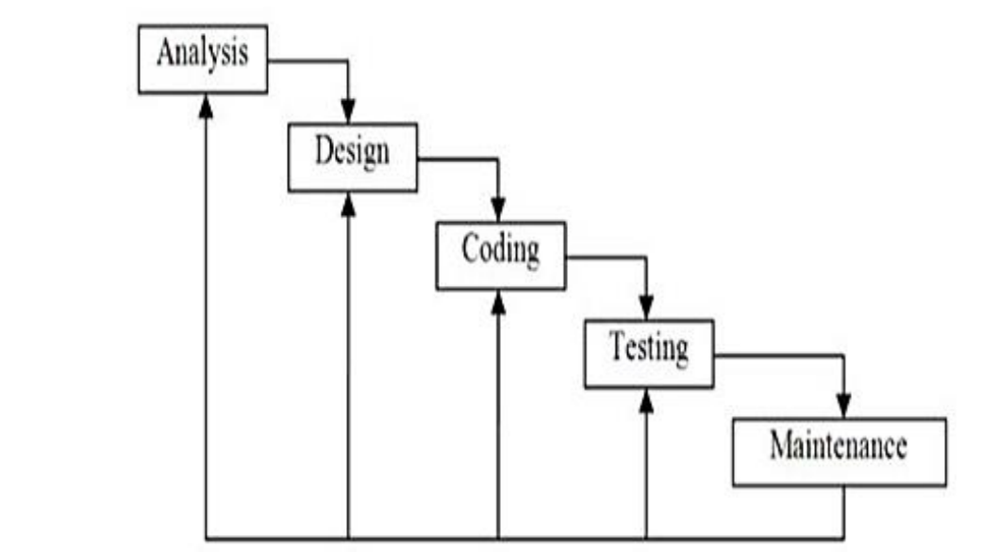

PROJECT DISCUSSION
In a system, it certainly has a process. The process of working here in terms of the stage of the system process itself. First, we open the product category, then select what products will be purchased, then put in the cart (shopping cart). In addition, if we are still going to buy other products we can continue shopping, but if it is done, then we do a checkout. What distinguishes the shopping process in the supermarket or the mini market that there is no request to write the identity of the buyer. In the online store website there is definitely an order form, because if it does not fill the order form, the seller cannot send the goods to customers who have bought the item. After the filled form is submitted, the process in the system is completed, and the consumer waits for the goods to come directly to the home or address.

CONCLUSION
After observing and understanding about how to build an Online Store Website using Hyper Text Markup Language programming language to promote and sell every product that is sold, it can be concluded that the online store creation page is divided into two, namely Administrator Page and Public Page. The website is created using My Structured Query Language or MySQL database and Hyper Text Markup Language programming language and then added some modules to make the display more interesting, such as Google Maps Module, Yahoo Messenger Module, and Two Language Module, so that consumers can see every product- products that have been updated and available at any time through the Website Shop Online. With the Website Shop Online buyers can see and can also order any product and buy any product without having to come to the store directly.

